Indexing

Contents

1. Introduction 2

Database Concepts: 2

How Computers Work with Arrays and Binary Search 4

2. How Indexes Work In Databases 6

Fundamentals Of Indexing 8

3. Index Creation and Maintenance 13

a. Initial Creation of Indexes 13

b. Maintenance and Updates of Indexes 14

Indexes - Practice 16

Creating Custom Indexes 17

4. Indexes on String Columns 19

Indexes on String – Practice 22

5. Full-Text Searches 25

Implementing Full-Text Search in MySQL 26

6. Composite Indexes 28

Query Performance with Composite Indexes: 30

# Introduction

## Database Concepts:

1. **Purpose of Databases**:
   * Store and retrieve data persistently.
   * Data is stored on persistent storage like HDD or SSD, not in RAM.
2. **Data Retrieval Process**:
   * Queries access data stored on disk.
   * Disk data is loaded into RAM because CPU cannot process data directly from disk.
   * CPU processes data in RAM for computations and checks.
3. **Speed Disparity**:
   * CPU is significantly faster than disk storage.
   * Direct interaction between CPU and disk would cause a bottleneck.
4. **Step-by-Step Query Execution**:
   * A query (e.g., SELECT * FROM STUDENTS WHERE PSP = 80) causes the database to fetch data from disk.
   * Data is loaded into RAM in manageable chunks (due to limited RAM size).
   * CPU processes each chunk, applying conditions, and results are returned.
5. **Memory Hierarchy**:
   * Disk → RAM → CPU workflow ensures efficient data handling.
   * Entire databases can't fit into RAM due to size limitations.
6. **Hardware Dynamics**:
   * Disk data is stored in concentric circles or sections.
   * Hardware reads sections sequentially, which is inherently slower than RAM access.
7. **Optimizations Needed**:
   * Direct processing of all rows for every query is slow, especially for large datasets.
   * Fetching data section by section into RAM helps manage memory constraints but still isn't optimal.

### **How data is stored and retrieved in a database**

* Think of a **disk** as a large array, say Disk[], where each element in the array represents a row in a database table.
* If you write a query like SELECT * FROM STUDENTS WHERE PSP = 80, you need to scan through each element of Disk[] to find rows where the condition PSP = 80 is true.
* However, the **CPU** cannot directly work with the Disk[] array because it’s too slow. Instead, data is **copied into a smaller array in memory (RAM)** for processing.

### **Why data is fetched in chunks**

* The size of the Disk[] array could be very large (e.g., 1 TB), but the size of the **RAM array** (say, RAM[]) is much smaller (e.g., 16 GB). Hence, you cannot copy the entire Disk[] into RAM[] at once.
* Instead, the database divides the Disk[] into smaller **sections** or **blocks**, and these blocks are fetched into RAM[] one by one.
* Example: If Disk[] has 1,000,000 rows, and RAM[] can hold 100,000 rows, you will process rows in **batches of 100,000**.

### **Sequential Scanning Without Indexes**

* Without an index, the query SELECT * FROM STUDENTS WHERE PSP = 80 requires scanning the entire Disk[] array. This is called a sequential scan:
  + Start at Disk[0], check the PSP value.
  + If it matches 80, copy the row to a Results[] array.
  + If it doesn’t match, move to the next element.
  + Repeat this until the end of Disk[].
* This process is slow because every element must be checked, even if only a few rows match the condition.

## **How Computers Work with Arrays and Binary Search**

### **1. Sequential Access in Arrays**

* Computers store arrays in **contiguous memory locations**.
* The **address of the first element** is stored (e.g., 100).
  + For integers, subsequent elements are spaced by 4 bytes:
  + Address of the first element = 100
  + Second element = 104
  + Third element = 108
  + Fourth element = 112
  + And so on...

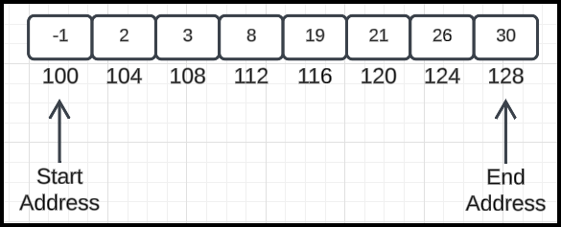

### **2. Calculating Array Boundaries**

* If the array has **8 elements** and each element takes **4 bytes**, then:
  + Start address = 100
  + End address = 100 + (8 - 1) * 4 = 128
* This allows the computer to determine the **total memory range** of the array (100 to 128).

### **3. Accessing Elements Mathematically**

* To find a specific element, the computer applies mathematics.
  + Example: To find the middle element in the array:
    - Middle index = (start_index + end_index) / 2
    - Address of the middle element = start_address + (middle_index * element_size)
    - For an array starting at 100 with 8 elements:
      * Middle element = at address 116.

### **4. Sequential Scanning vs. Binary Search**

### **Sequential Scanning**

* Without applying any optimization, finding an element requires scanning **each element one by one**.
* This involves **more disk accesses**:
  + Example: To find the number 3 in the array, you may need **4 disk accesses**:
    1. Fetch data from Disk[0], check if it matches.
    2. Fetch data from Disk[1], check again.
    3. Repeat for the next addresses until the number is found.

### **Binary Search**

* With **binary search**, the computer uses the sorted structure of the array to minimize the number of checks:
  + Start with the **middle element**.
  + If the target is smaller, search the **left half**.
  + If larger, search the **right half**.
  + Repeat until the target is found.

### **Number of Disk Accesses in Binary Search**

* Binary search requires **log(n) disk accesses**, where n is the number of elements.
* Example: To find the number 3 in the array:
  + First disk access: Fetch the middle element (116), check if it matches.
  + Second disk access: Fetch the left or right half of the array, depending on the comparison result.

### **5. Role of Disk Accesses and Indexing**

* **Disk access** is a slow operation compared to accessing data in RAM.
* Transferring large amounts of data from disk to RAM for computation is inefficient.
* **Indexes** aim to reduce the number of disk accesses, making operations faster.
  + Example:
    - Without indexing: **4 disk accesses** to find an element.
    - With indexing and binary search: **2 disk accesses**.

### **Key Insight:**

Indexes improve efficiency by reducing the **number of disk accesses**, which directly speeds up data retrieval.

# How Indexes Work In Databases

**Disk Access is Slow**

* Databases store most of their data on disk by default. Disk access is inherently slower than accessing data from RAM. To improve query performance, the number of disk accesses must be minimized.

**Primary Keys and Sorted Storage**

* By default, databases often store data sorted by the **primary key**. This allows queries like SELECT * FROM STUDENTS WHERE ID = X to be efficient even without additional optimizations. However, this alone isn't always enough.

**Hash Maps for Faster Access**

* A **hash map** allows for fast lookup (average-case O(1) time complexity) by mapping keys (e.g., student IDs) to values (e.g., addresses or data).
* However, hash maps stored **on disk** do not provide the same speed benefits because disk access remains the bottleneck.
* Hence, a hash map or similar structure must reside **in RAM** for effective use.

**Indexes as a Solution**

* **Indexes** are auxiliary data structures stored in memory to speed up data retrieval.
* 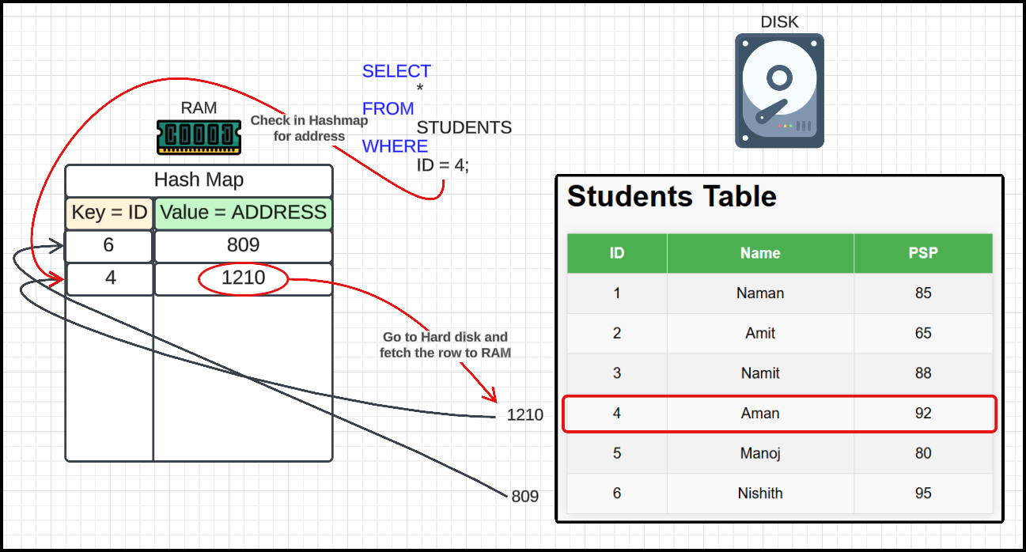They map keys (e.g., student IDs) to pointers or addresses where the actual data resides on disk.
* With an index, instead of scanning the entire table, the database can directly retrieve the address from the index and fetch the data in a **single disk access**.

**Trade-offs**

* While indexes significantly reduce query time, they come at the cost of increased storage and memory usage.
* Maintaining indexes also increases the time complexity of **write operations** (inserts, updates, and deletes) since the index must be updated alongside the actual data.

### **How This Works in Practice**

* **Scenario:**  
  A query like SELECT * FROM STUDENTS WHERE ID = X needs to fetch data for a specific student.
* **Without Index:**
  + The database might perform a **linear search** through the table, leading to O(n) disk accesses.
* **With Index:**
  + The database uses an **in-memory index** to determine the disk address of the required student in O(1) or O(log n) time. Then it performs a **single disk access** to fetch the data.

## Fundamentals Of Indexing

1. Hash Length and Table Size:

The hash length corresponds to the number of distinct keys or rows. Handling large data for operations like DISTINCT requires all data to be loaded into RAM, posing potential memory limitations.

1. Limitations of Indexing:

Indexes do not eliminate the need for scanning rows entirely in certain queries, such as SUM. They merely optimize access by reducing the number of disk reads.

1. Trade-offs in Computer Science:

Everything in computer systems, including indexing, involves trade-offs. While indexes speed up certain queries, they introduce storage overhead and might slow down write operations.

1. Indexes and Data Organization:

Indexes store mappings (e.g., key to addresses) rather than every row individually. They optimize by grouping rows or storing pointers to disk locations, minimizing the need for multiple disk accesses.

1. Query Optimization via Hash Maps:

A hash map in RAM can link a key (e.g., PSP) to disk addresses where data resides. This avoids scanning all rows but does not guarantee that each section contains only relevant data, as disk sections may include unrelated rows.

1. Disk Access Patterns:

Disks fetch data in sections, not byte by byte, due to the high cost of individual disk accesses. Fetching a section ensures multiple rows are brought into RAM in a single operation.

1. Analogy for Understanding Sections:

The relationship between disk sections and rows is likened to identifying which train bogie contains a specific seat. A bogie may include other unrelated seats, similar to a disk section containing rows with different attributes.

1. Challenges of Handling Large Data:

Operations like DISTINCT or SUM require careful consideration of memory and storage constraints. Efficient indexing and data partitioning strategies help mitigate these challenges.

* What happens when column values are updated but the index is not updated?
  + If the index is not updated when column values change, the index becomes inconsistent. This inconsistency leads to incorrect or inefficient query results. For example, if a phone number in a database changes but its index isn't updated, querying the phone number using the index will fail.
  + In databases:
    - **Reads become faster** because the index provides a direct or near-direct path to the data.
    - **Write, update, and delete operations become slower** because they involve updating the index as well, leading to additional computational overhead.
* Why do hash maps fail for range queries?
  + Hash maps are efficient for exact matches, but they struggle with range queries (e.g., PSP >= 70 AND PSP <= 90). This is because:
    - Hash maps store data based on hash values derived from keys, and these hash values are distributed arbitrarily.
    - Finding values in a range requires traversing the entire hash map, resulting in O(n) time complexity for range queries.
* What data structure can efficiently handle range queries?
  + A **binary search tree (BST)** is a suitable data structure for range queries because:

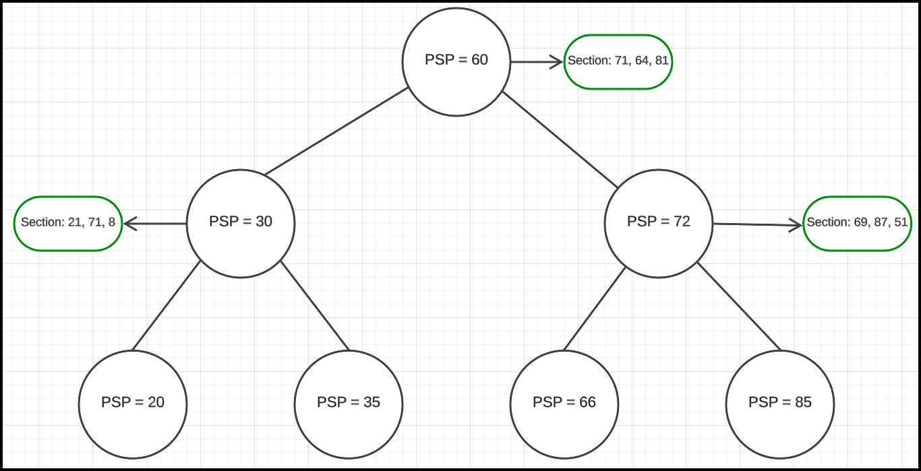

* + - It is inherently sorted, allowing efficient traversal of elements in a specific range.
    - The time complexity to find a specific value is O(log n) in a balanced BST.
    - Moving to the next greater value (successor) is also efficient, allowing quick iteration through a range.

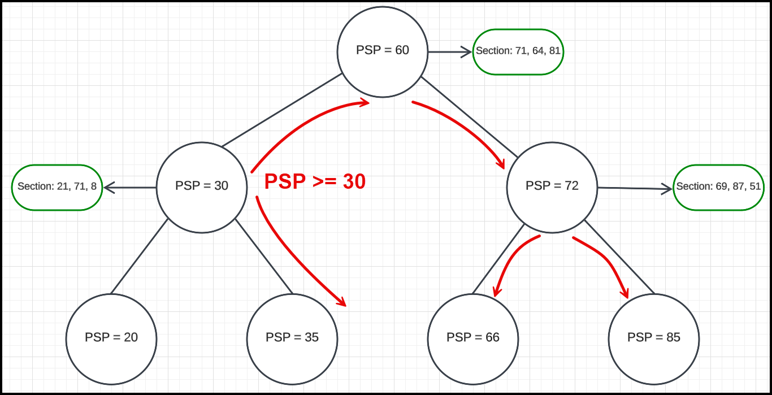

* Example: Processing a range query with a binary search tree
  + For a query like:

SELECT

    *

FROM

    STUDENTS

WHERE

    PSP >= 30

    AND PSP <= 90;

* + Steps:
    - Start at the root and find the smallest value (≥30).
    - Traverse the tree, visiting nodes in sorted order.
    - Stop once a node with a value >90 is encountered.
  + The above process efficiently retrieves all matching records.
  + By combining indexing strategies and appropriate data structures, databases achieve a balance between read and write performance, catering to diverse query requirements.
* Real-world usage of a tree-based index
  + Databases use tree-based structures like **B-trees** or **B+ trees** to implement indexing:

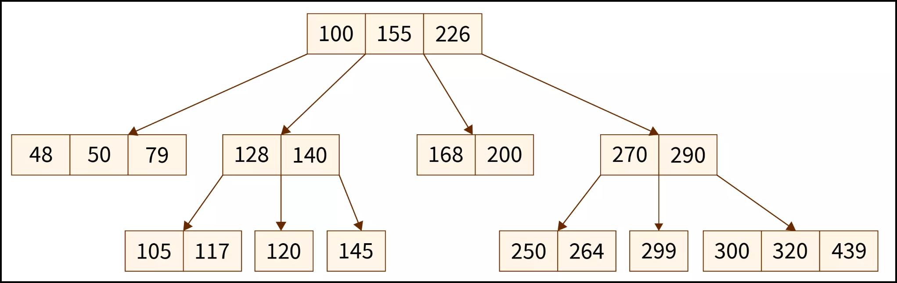

* + - These structures are optimized for disk-based storage and allow efficient range queries and sequential access.
    - Each node in the tree may store key-value pairs and pointers to child nodes.
    - This setup enables efficient insertion, deletion, and traversal operations, making them ideal for managing large-scale database indexes.

# Index Creation and Maintenance

Indexes in databases are data structures that help improve the performance of queries by allowing faster data retrieval. However, the creation and maintenance of indexes come with trade-offs. Here’s a detailed explanation of how indexes are created and updated, addressing the two main aspects: **initial creation** and **maintenance/updates**.

## **Initial Creation of Indexes**

### **Approach 1: In-Memory Index**

* The index is stored only in the **RAM (volatile memory)**.
* When the database starts:
  + The index is recomputed from the rows stored on the disk.
  + The system traverses every row in the database and reconstructs the index structure (e.g., a B-Tree or a Hash Map).
* **Advantages:**
  + **Write operations** are faster because updates only affect the in-memory index.
  + **Storage requirements** are lower since the index is not stored persistently on the disk.
* **Disadvantages:**
  + If the machine restarts or crashes, the index is lost because RAM is volatile.
  + Upon restart, the system has to **recompute the index**, leading to slower **startup times**.

### **Approach 2: Persistent Index**

* The index is stored both in **RAM** and on the **disk** (persistent storage).
* When the database starts:
  + The index is directly loaded from the disk into memory.
  + This eliminates the need to recompute the index from the rows on the disk.
* **Advantages:**
  + Faster **startup times**, as the index is readily available from the disk.
  + Once loaded, queries can execute immediately without delay.
* **Disadvantages:**
  + **Write operations** become slower because updates need to be made in two places:
    - The in-memory index.
    - The on-disk index.
* Requires more **storage space** since the index is stored persistently.

## **Maintenance and Updates of Indexes**

* Indexes must be kept up-to-date to remain effective. This happens during **write operations** (e.g., INSERT, UPDATE, or DELETE queries). Here's how the updates are handled:

### **Impact of Write Operations:**

* When a value in the indexed column changes, the database must:
  + Locate the old value in the index structure and remove it.
  + Insert the new value into the appropriate position in the index.

### **In-Memory Index Maintenance:**

* Updates are made only to the in-memory copy of the index.
* **Advantages:**
  + Write operations are faster since there is no need to sync changes to the disk.
  + Ideal for scenarios where write performance is critical, and occasional downtime for index re-computation is acceptable.
* **Disadvantages:**
  + The index is volatile. If the system crashes, the updates are lost, and the index must be rebuilt during startup.

### **Persistent Index Maintenance:**

* Updates are made to both the in-memory and on-disk copies of the index.
* **Advantages:**
  + The index remains consistent and reliable across restarts or crashes.
  + Ideal for scenarios where immediate availability after a restart is critical.
* **Disadvantages:**
  + Write operations are slower since every update must be written to both RAM and disk.

### **Trade-Offs Between the Two Approaches**

| **Approach** | **Startup Time** | **Write Speed** | **Read Speed** | **Reliability** |
| --- | --- | --- | --- | --- |
| **In-Memory Index** | Slow (needs re-computation) | Fast | Fast | Low (index lost on restart) |
| **Persistent Index** | Fast (loaded from disk) | Slow (dual updates) | Fast | High (index persists) |

### **Example Scenario:**

* Consider a database storing student information, indexed by their PSP (Problem-Solving Percentage).
* **Initial Creation:**
  + **In-Memory Index:** The database scans all student records and constructs the index in RAM.
  + **Persistent Index:** The database fetches the pre-existing index from disk and loads it into RAM.
* **Maintenance:**
  + When a student's PSP changes (e.g., from 60 to 81), the database must:
    - **In-Memory Index:** Update the in-memory structure only.
    - **Persistent Index:** Update both the in-memory and on-disk structures.

### **Conclusion**

* Choosing between **in-memory** and **persistent** indexes depends on the application's requirements:
  + **In-Memory Indexes** prioritize fast write operations but involve slower startup times and potential data loss during crashes.
  + **Persistent Indexes** ensure reliability and faster startups but make write operations slower due to additional overhead.

## **Indexes - Practice**

* An index is a data structure that improves the speed of data retrieval operations on a database table.
* Types of indexes:
  + **Primary Index**: Automatically created on the **primary key** of a table.
  + **Foreign Key Index**: Created for **foreign key** columns to maintain referential integrity.
  + **Custom Indexes**: Can be created on specific columns to optimize query performance.

### **Default Index on Primary Key**

* Every table automatically has an index on its primary key.
* Example: In the PRODUCTS table, an index is automatically created on the PRODUCT_ID column.
* The type of index used is typically **B-Tree**.

### **How Indexes Work**

* Without an index:
  + The query must scan all rows in the table (full table scan).
  + Example:

SELECT * FROM

    PRODUCTS

WHERE

    QUANTITY_IN_STOCK = 49;

* If there are 10 rows in the table, the query will scan all 10 rows.

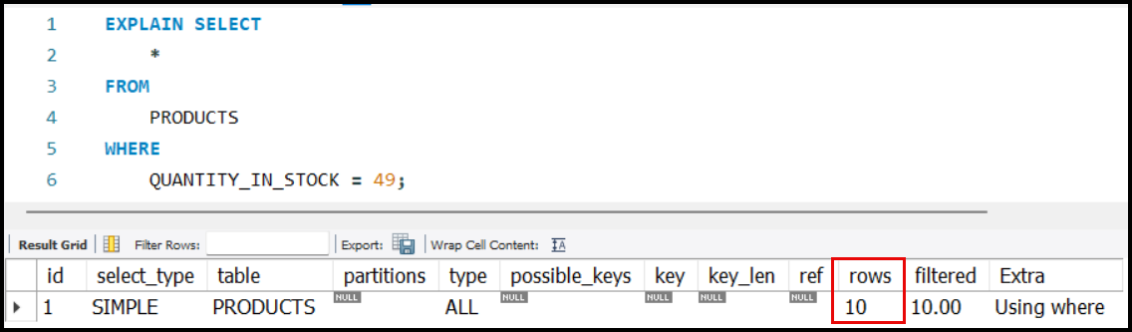

* With an index:
  + The query can locate rows directly, reducing the number of rows scanned.
  + Example:

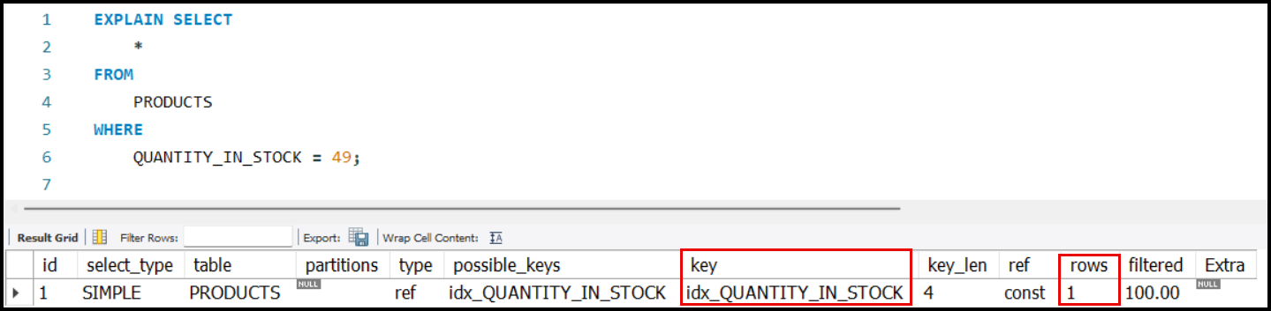CREATE INDEX IDX_QUANTITY_IN_STOCK ON PRODUCTS(QUANTITY_IN_STOCK);

* + - The query scans only 1 row because it uses the newly created index on QUANTITY_IN_STOCK.

## **Creating Custom Indexes**

* **Syntax**:
  + Example:

CREATE INDEX

    IDX_<TABLE_NAME>_<COLUMN_NAME>

ON

    <TABLE_NAME>(<COLUMN_NAME>);

CREATE INDEX

    IDX_QUANTITY_IN_STOCK

ON

    PRODUCTS(QUANTITY_IN_STOCK);

* Naming Convention:
  + Start with IDX_.
  + Include the table name and the column name in the index name for clarity.

### **Understanding** EXPLAIN **in SQL**

* The EXPLAIN keyword provides insights into how a query is executed.
  + **Possible Keys**:
    - Lists all the indexes that might optimize the query.
    - Example: If querying on QUANTITY_IN_STOCK, an index on PRODUCT_ID is not a "possible key."
  + **Key**:
    - The actual index used by the query.
    - If multiple indexes are possible, the database optimizer chooses the most efficient one.

### **Effect of Indexes on Query Performance**

* Indexes make read operations faster:
  + For example, searching for a specific value in an indexed column requires scanning fewer rows.
* Indexes may increase the time taken for write operations (e.g., INSERT, UPDATE, DELETE), as the index structure needs to be updated.

### **Key Differences: Possible Keys vs. Key**

* **Possible Keys**:
  + All indexes that might optimize a query.
  + Example: An index on QUANTITY_IN_STOCK is a possible key for queries filtering by QUANTITY_IN_STOCK.
* **Key**:
  + The actual index used by the database to execute the query efficiently.

### **Important Points**

* Primary key indexes are automatically created for primary key columns.
* Custom indexes must be created explicitly for other columns to optimize specific queries.
* Use EXPLAIN to analyze how queries interact with indexes.
* While indexes improve read performance, they can slightly degrade write performance due to the need to maintain the index structure.
* Use indexes for frequently queried columns.
* Avoid excessive indexing, as it can negatively impact write performance.

# Indexes on String Columns

### Scenario:

* Example table: STUDENTS with columns: ID, NAME, PSP, EMAIL.
* A common query:

SELECT

    *

FROM

    STUDENTS

WHERE

    NAME = 'SOME_NAME';

|  |  |
| --- | --- |
| RAM | |
| Key | Address |
| Atul | 101 |
| Aman | 351 |
| Naman | 104 |
| Nitin | 241 |
| Naman | 110 |
|  |  |
|  |  |
|  |  |
|  |  |
|  |  |
|  |  |

* High-frequency queries on NAME might lead to creating an index on the NAME column.

### How Indexes Work:

* Indexes in RAM typically store:
  + Key: The value being indexed (e.g., NAME).
  + Address: The location of the data on the disk.
* For a string index, the key will be the string itself (e.g., Atul at address 101).

### Problems with String Indexes:

* Size of the Index:
  + Storing strings as keys consumes a lot of memory.
  + Example:
    - 1 million rows with an average name length of 20 characters.
    - 20 bytes per name → 20 MB for the index map.
    - For larger datasets (e.g., 10–100 million rows), the size increases exponentially.
  + Email column exacerbates the issue:
    - Emails (average length ~50 characters).
    - 1 million rows → 50 MB index size.

### String Comparison Time Complexity:

* String comparisons are O(n), where n is the string length.

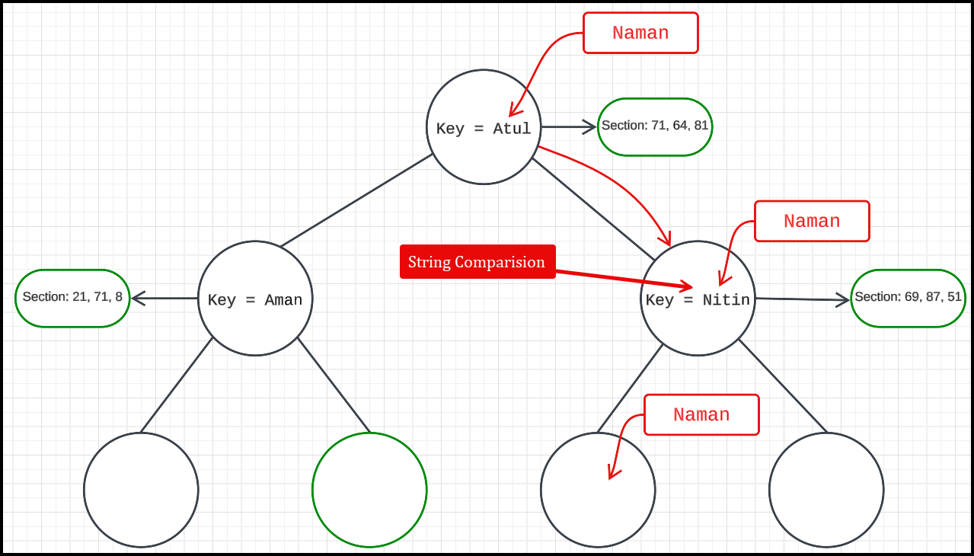

* Searching in a tree structure:
  + Tree height is log(n) for balanced trees.
  + Each node requires string comparison → Total complexity is O(n * log(n)).
* Larger datasets and deeper trees make traversing and comparison inefficient.

### Key Challenges with String Indexing:

* Large Index Size:
  + Storing long strings for large datasets increases memory usage.
* Search Inefficiency:
  + Each comparison requires traversing the string, leading to higher time complexity.
  + Both issues worsen as the dataset grows.

### Example:

* For the email column with 10 million rows and average size 50 bytes per email:
  + Index size = 50 bytes × 10M rows = 500 MB.
* Traversing such large trees for string comparisons further impacts performance.

### Key Concepts and Observations

* Database Index Trade-Off:
* A database index can make queries faster but increases storage requirements.
* There is a trade-off between speed and size when choosing an indexing strategy.
* Reduction of Index Size:
* Full name indexing results in better speed (fewer sections to search) but has a higher size.
* Indexing only on the first character reduces index size but increases the number of sections to scan, slowing queries.
* Intermediary Approaches:
* Indexing on a subset of characters (e.g., first 2 or 3 characters) balances speed and size.
* The more characters included in the index, the fewer sections need to be searched, but the index size grows.
* Impact of Uniform Distribution:
* The assumption of equally likely characters/pairs simplifies calculation:
* For 10 million rows, indexing:
  + On 1-character divides rows into sections.
  + On 2 characters divides rows into ​.
  + On 3 characters divides rows into ​.

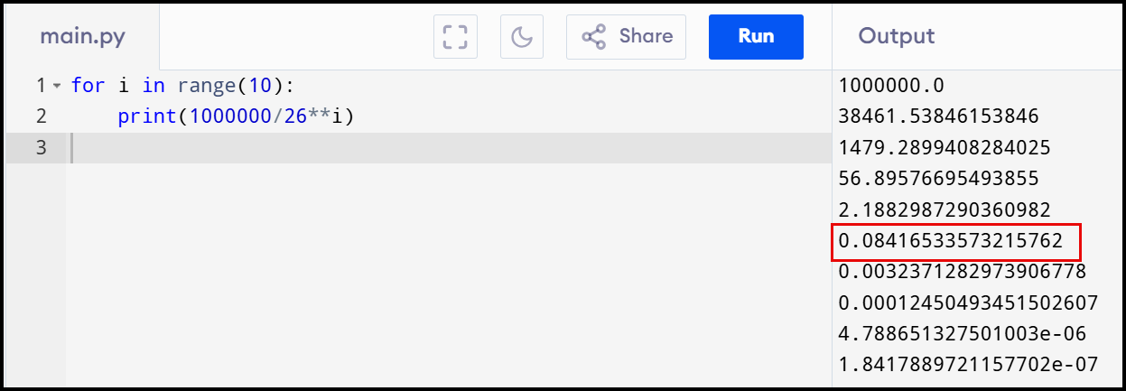

### **Indexing for String** Columns

* Instead of creating an index on the **entire column**, consider creating an index on the **first part of the column** for string-based cases.
  + **Why?**
    - It can improve performance.
    - Reduces the overhead of indexing the entire column.

## Indexes on String – Practice

### **Query Behavior** Without **an Index**

* Example Query:

EXPLAIN SELECT

    *

FROM

    CUSTOMERS

WHERE

    FIRST_NAME = 'NAMAN';

* 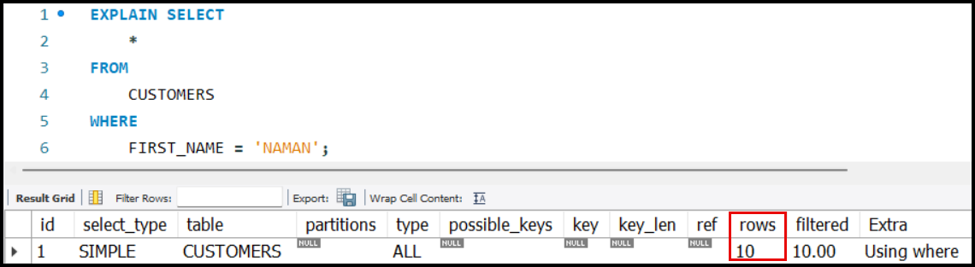Without an index, the query has to perform a **full table scan**, going through all rows (e.g., 10 rows if the table contains 10 entries).

### **Creating a Full-Column Index**

* **Syntax to Create an Index:**

CREATE INDEX

    IDX_CUSTOMERS_FIRST_NAME_ALL

ON

    CUSTOMERS(FIRST_NAME);

* **Effect**:
  + The query will utilize the index, reducing the rows scanned to just the ones matching the exact value (e.g., only 1 row if "Number" exists).
  + 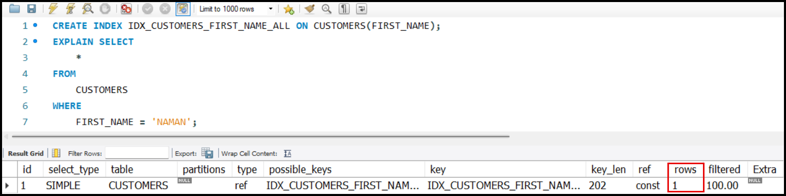If "Number" does not exist, it checks only the index and skips scanning all rows.
* **Dropping the Index:**

DROP INDEX IDX_CUSTOMERS_FIRST_NAME_ALL ON CUSTOMERS;

### **Partial Indexing: Indexing on the First Character**

* Instead of indexing the **entire column**, an index can be created on the **first character** of the column.
* **Syntax to Create a Partial Index**:

CREATE INDEX

    IDX_CUSTOMERS_FIRST_NAME_CHAR

ON

    CUSTOMERS(FIRST_NAME(1));

* + FIRST_NAME(1) specifies that the index is created only on the first character of the FIRST_NAME column.

### **Behavior with a Partial Index**

* **Query Example**:

EXPLAIN SELECT * FROM CUSTOMERS

WHERE FIRST_NAME = 'INES';

* **Effect**:
* The index helps narrow down the rows to only those whose FIRST_NAME starts with the same character.
* The query performance improves as it scans fewer rows compared to a full table scan.
* For example:
  + If only one name starts with "N," only that row is scanned.
  + 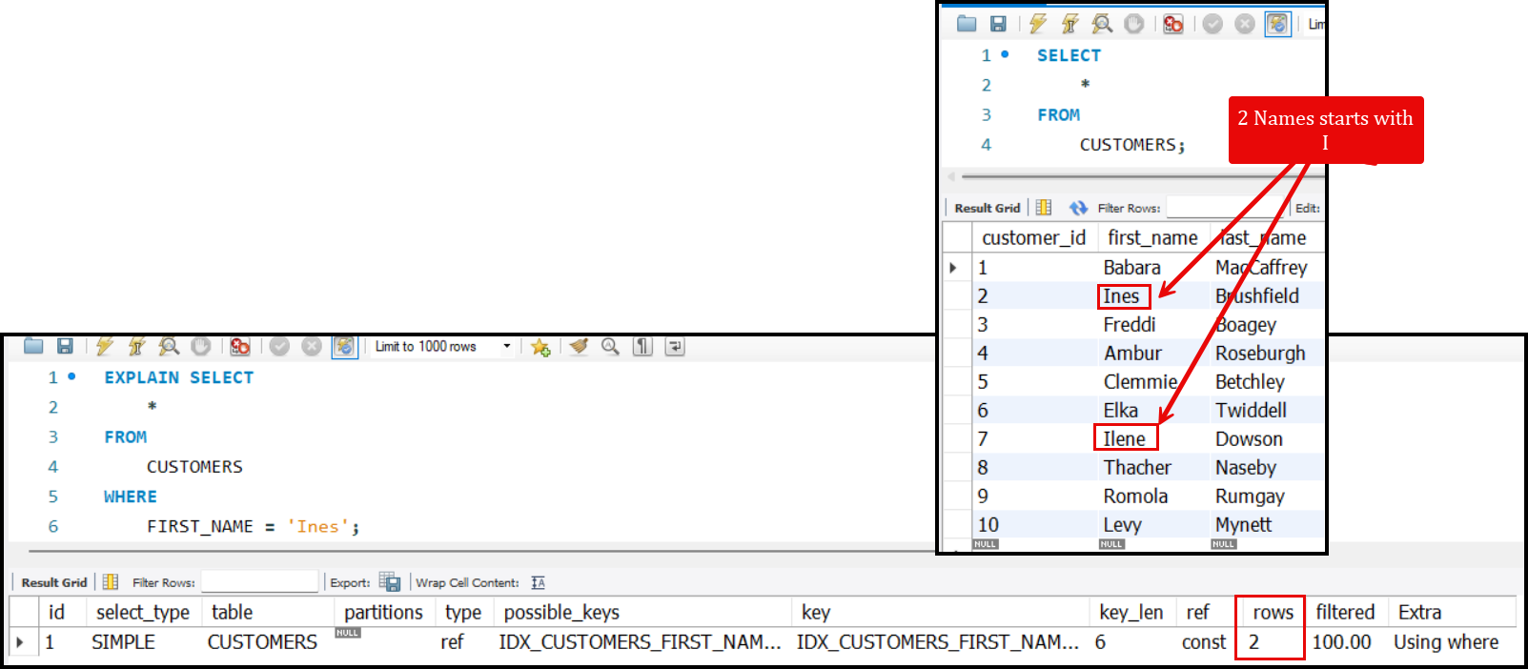If multiple names (e.g., "INES") exist, all rows starting with "I" are scanned.

### **Key Insights**

* **Partial Indexes**: Useful for improving performance in cases where only the initial part of a string is frequently queried.
* **Trade-offs**:
  + Scans fewer rows than a full table scan.
  + Slightly less efficient than a full-column index for exact matches.
* **Application**: Effective for large datasets where full-column indexing is unnecessary or computationally expensive.

# Full-Text Searches

### Table Design:

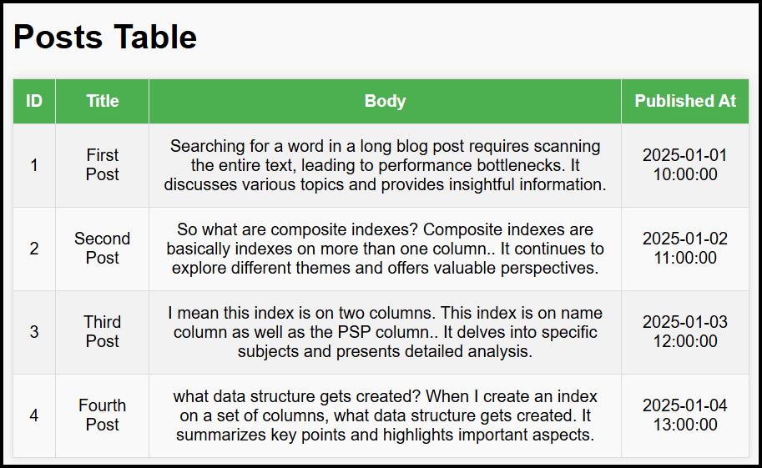

### Scenario: Blogging Website

* Search Requirements:
  + Search posts containing specific keywords (e.g., "Index").
  + Combine keywords with logical operators (e.g., " Index AND data").
  + Exclude keywords (e.g., " Index but NOT Names").

### **Limitations of Traditional Indexing**

* **Indexes (e.g., B-Tree)**:
  + Optimized for prefix-based string searches or exact matches.
  + Inefficient for searching large text fields where keywords can appear at any position.
  + Example:
    - Searching for a word in a long blog post requires scanning the entire text, leading to performance bottlenecks.

### **Advanced Search Solutions**

* **Elasticsearch**:
  + Designed for full-text search at scale.
  + Uses **inverted index**:
    - A data structure mapping words to the documents they appear in.
    - Highly efficient for keyword-based searches.
* **MySQL Full-Text Index**:
  + Built-in support for basic full-text search.
  + Uses **inverted index** internally, not B-Trees.
  + Useful for smaller systems or when external tools like Elasticsearch are unnecessary.

## Implementing Full-Text Search in MySQL

### Without Index:

* Query:

EXPLAIN SELECT

    *

FROM

    POSTS

WHERE

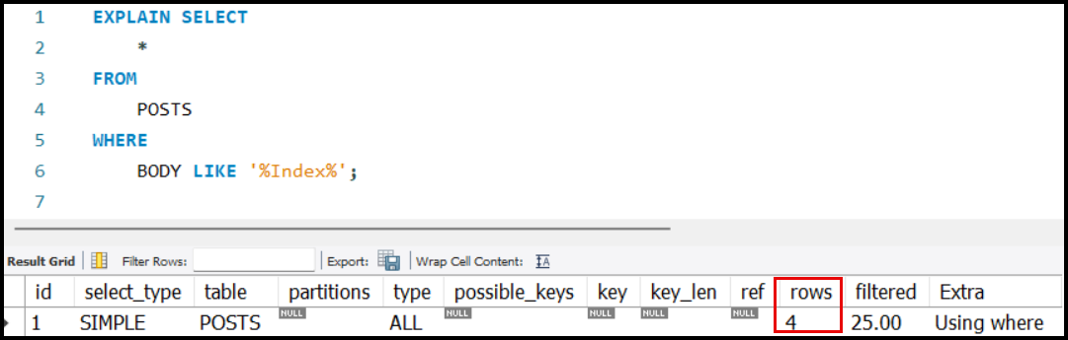    BODY LIKE '%Index%';

### Creating a Full-Text Index:

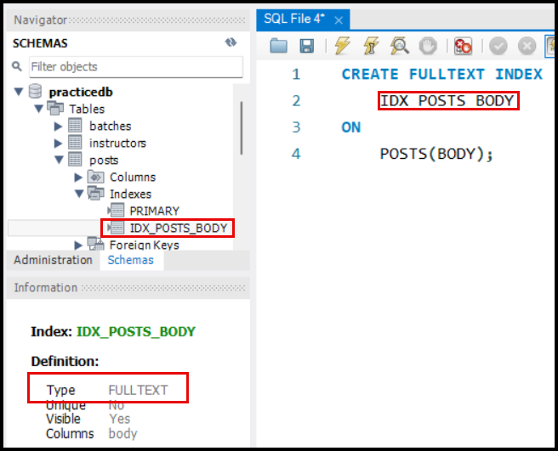CREATE FULLTEXT INDEX

    IDX_POSTS_BODY

ON

    POSTS(BODY);

* FULLTEXT index type allows for efficient keyword searches.
* Applicable to TEXT or VARCHAR columns.

### Querying with MATCH and AGAINST:

* Example:

SELECT

    *

FROM

    POSTS

WHERE

    MATCH(BODY) AGAINST('Index');

* Features:
  + Searches the BODY column for posts containing the word 'Index'.
  + 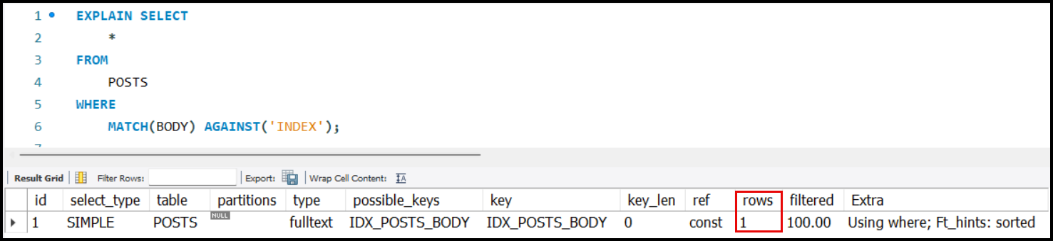Leverages the full-text index for efficiency.

### Advanced Search Queries:

* Search with multiple keywords:

SELECT

    *

FROM

    POSTS

WHERE

    MATCH(BODY) AGAINST('Composite indexes');

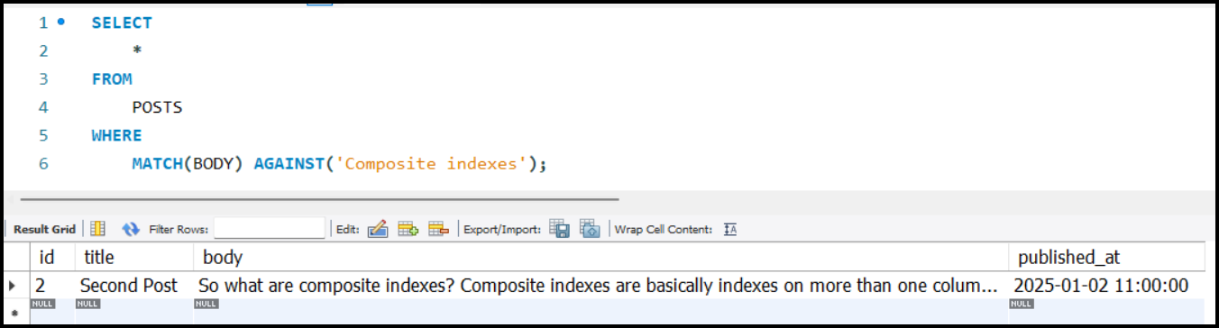

# Composite Indexes

* **Definition:** Indexes created on multiple columns, e.g., (NAME, PSP).
* **Behavior:**
  + The index is **ordered primarily by the first column** and secondarily by the second column (tie-breaker).
  + Example: An index on (NAME, PSP) sorts rows first by NAME, then by PSP for identical names.
* **Purpose of Indexes**:
  + Indexes are created on a set of columns to improve the speed of data retrieval operations.
* **Underlying Data Structure**:
  + When an index is created, a **Tree Map** data structure is generated.
* **Behavior of the Tree Map:**
  + The **nodes** in the tree are **ordered by the first column** specified in the index.
  + If two rows have the **same value** for the first column, the **tie breaker** will be the next column in the index.

CREATE INDEX INDEX_NAME ON STUDENTS (NAME, PSP);

#### **Explanation Through Example**:

* **Data in the Students Table**:

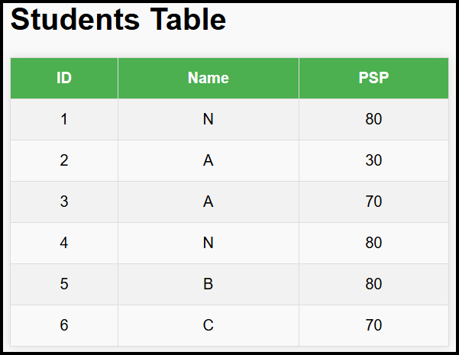

* **Order Based on the Index**:
  + Primary column for ordering: NAME
  + Secondary column for ordering: PSP
* **Resulting Order in the Index**:

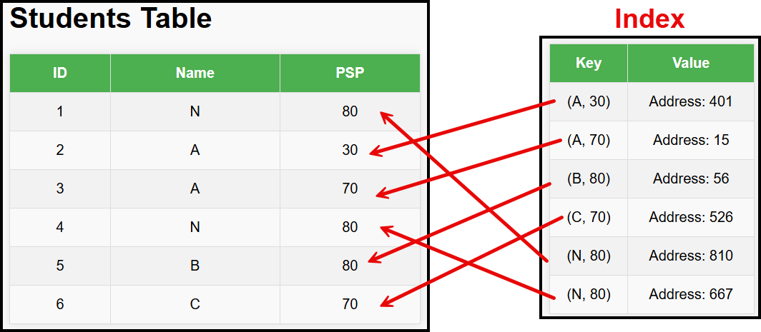

## Query Performance with Composite Indexes:

* **Single-Column Match:**
  + A query like SELECT * FROM STUDENTS WHERE NAME = 'N' benefits from the composite index, as rows are sorted by NAME.
* **Multi-Column Match:**
  + A query like SELECT * FROM STUDENTS WHERE NAME = 'N' AND PSP = 80 is efficient. The composite index helps locate NAME matches, and PSP serves as a tie-breaker.
* **Second-Column Match Only:**
  + A query like SELECT * FROM STUDENTS WHERE PSP = 80 does not benefit significantly from the composite index because the rows are not ordered by PSP. To find all occurrences of PSP = 80, the database needs to scan through the entire index, as PSP is the second column in the index, and the index is primarily ordered by the first column (e.g., NAME).

### Summary with an example

* A composite index is created on multiple columns (e.g., A, B, C), and the order of the columns in the index determines how queries can leverage it.
* The key takeaway is that **queries will be faster only if there is a matching prefix** in the query columns that aligns with the order of the indexed columns.

#### **Matching Prefix**:

* A query benefits from the composite index only if it starts with the same order of columns as defined in the index. For example:
  + If the index is on A, B, C, a query on A, A and B, or A, B, and C benefits because they form prefixes of the index.
  + Queries on C, B, or B and C will not be faster, as they do not match the prefix order of the index.

#### **Partial Matches**:

* Queries involving partial prefixes (e.g., A and C) may see some benefit because the index can help filter rows starting with A, but the performance gain will not be as significant.

#### Table: Queries and Index Benefit

| **Query Columns** | **Index Columns** | **Matching Prefix** | **Faster Query** | **Reason** |
| --- | --- | --- | --- | --- |
| A | A, B, C | A | Yes | The query matches the first column of the index. |
| B | A, B, C | None | No | Rows are not sorted by B; no prefix match. |
| C | A, B, C | None | No | Rows are not sorted by C; no prefix match. |
| A, B | A, B, C | A, B | Yes | Matches the first two columns of the index. |
| A, C | A, B, C | A | Partially | Matches A; partial benefit, but not fully efficient. |
| B, C | A, B, C | None | No | No matching prefix; rows are not ordered by B or C. |
| A, B, C | A, B, C | A, B, C | Yes | Matches all columns in the index; fully efficient. |

#### Summary

* A **composite index** improves query performance **only when there is a matching prefix** in the query columns.
* Queries starting with the **leftmost indexed columns** (e.g., A, A and B, A, B, and C) benefit from the index.
* Queries with columns that skip or reorder indexed columns (e.g., C, B and C) do not benefit, as there is no prefix match.
* **Partial matches** (e.g., A and C) may offer limited performance improvements.

### **SQL Query Optimization with Indexes**

* **Indexes Overview:**
  + Indexes are used to speed up queries by narrowing down the rows to be scanned.
  + Example:
    - **Index 1:** (A, E)
    - **Index 2:** (B, C)
* **Scenario**:
  + Query:

SELECT

    *

FROM

    STUDENTS

WHERE

    A = SOME_VALUE

    AND B = SOME_VALUE

    AND D = SOME_VALUE;

* + Both indexes are valid, as they can help filter rows based on conditions.
* **Selection Criteria:**
  + SQL chooses the index that leaves fewer rows to process after filtering.
  + Fewer rows to process = faster query execution.
* **Cardinality:**
  + **Definition:** The number of unique values in a column.
  + Higher cardinality = More selective index = Fewer rows to process.
  + Example:
    - Column A: 5,000 unique values → Leaves 2 rows per value.
    - Column B: 10 unique values → Leaves 1,000 rows per value.
* **Rule of Thumb:**
  + Use the index with higher cardinality in its **first column** for better performance.

### **Practical Example:**

* Table has 10,000 rows.
* Column A: 5,000 unique values (e.g., NAME).
* Column B: 10 unique values (e.g., BATCH_ID).
* Query:

SELECT

    *

FROM

    STUDENTS

WHERE

    NAME = 'JOHN'

    AND BATCH_ID = 1;

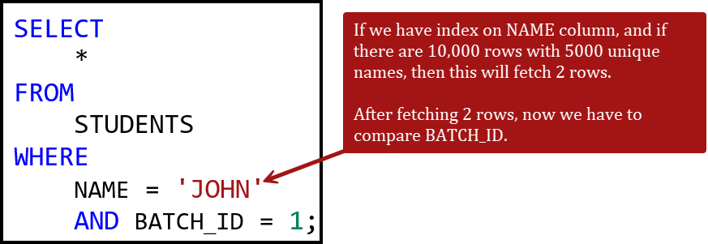

* Index on A is better because it filters to 2 rows (10,000 / 5,000).
* Index on B filters to 1,000 rows (10,000 / 10).

### **Key Takeaways:**

* Higher cardinality in the first column of an index improves efficiency.
* SQL optimizers aim to minimize the rows processed serially after index filtering.

### Composite Index - Practice

* 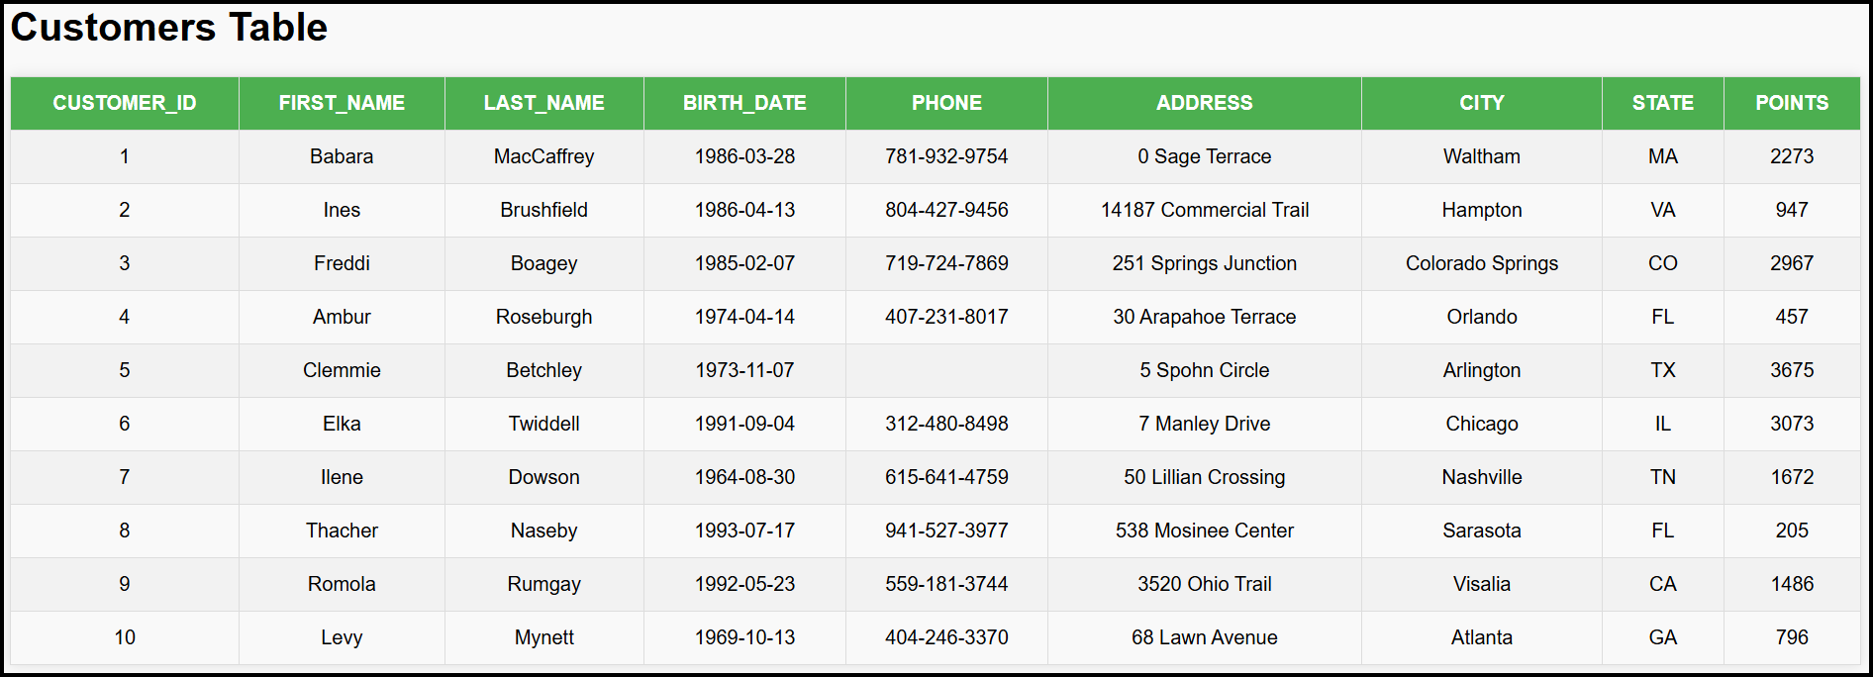We have a CUSTOMERS table…
* Creating Composite Index

CREATE INDEX

    IDX_STATE_POINTS

ON

    CUSTOMERS(STATE, POINTS);

* Question: SQL Query

SELECT

    *

FROM

    CUSTOMERS

WHERE

    STATE = 'MA';

* Does the above query use the index (IDX_STATE_POINTS) that we have created?
  + 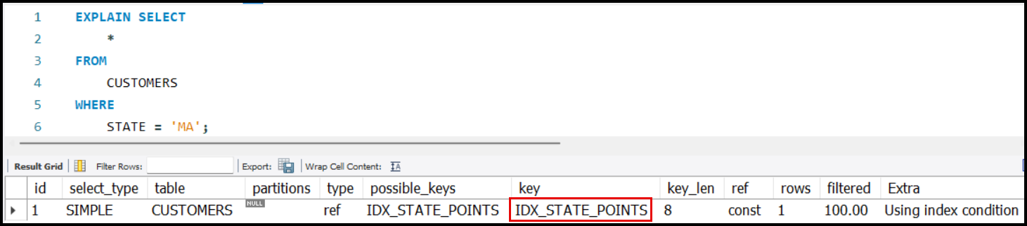Answer: YES!
* Question: SQL Query

SELECT

    *

FROM

    CUSTOMERS

WHERE

    POINTS > 100;

* Does the above query use the index (IDX_STATE_POINTS) that we have created?
  + 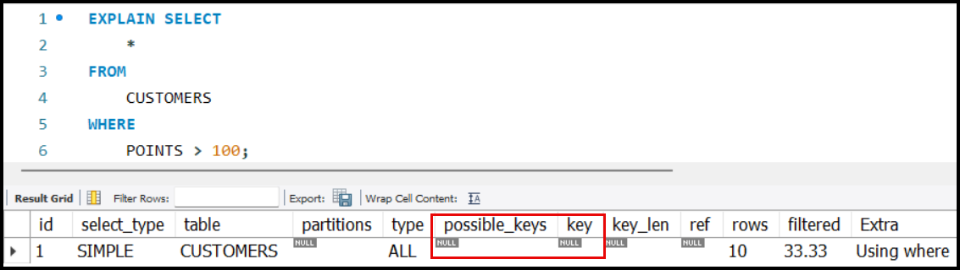Answer: No!
* Creating One More Composite Index

CREATE INDEX

    IDX_FIRST_NAME_POINTS

ON

    CUSTOMERS(FIRST_NAME, POINTS);

* Question: SQL Query

SELECT

    *

FROM

    CUSTOMERS

WHERE

    FIRST_NAME = 'AMBUR'

    AND POINTS > 100;

* Which index SQL will use and why?
  + The composite index IDX_FIRST_NAME_POINTS **will be used** for this query.
* Why**?**
  + **Prefix Match:**
    - The condition FIRST_NAME = 'AMBUR' matches the **leading column** (FIRST_NAME) of the composite index.
  + SQL can efficiently locate all rows where FIRST_NAME = 'AMBUR'.
* **Accessing the Second Column:**
  + After finding rows where FIRST_NAME = 'AMBUR', SQL can then efficiently filter rows using the second column POINTS > 100 without needing to scan the full table.
* **Efficiency:**
  + Using the composite index significantly reduces the number of rows to process because it:
  + Narrows the rows using FIRST_NAME = 'AMBUR' (via the index's leading column).
  + 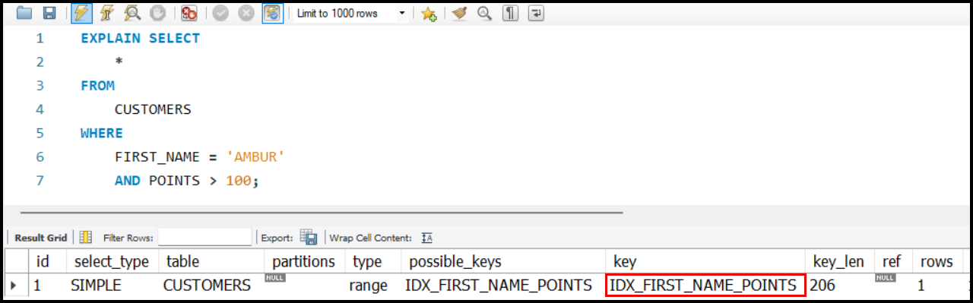Further filters the rows using POINTS > 100 (via the second column in the index).